Project
Plan
Summary

Emanon College Lab Build Project

Project ID: | 2009-19
Prepared By: | Rebecca Brown
Position: | Project Manager
Company: | Emanon College
Date: | 27 Feb 2009

Table of Contents
Project Overview 3
Background 3
Need/Requirement 3
Objectives 3
Project Scope 3
Deliverables 3
Scope Exclusions 5
Updated Detailed Assumptions 6
Constraints 6
Project Approach/Phases 6
High Level Tasks: 6
Project Resources 7
Key Personnel Responsibilities 7
Labour 8
Material 8
Project Schedule 9
Schedule 9
Key Project Milestones 9
Project Budget 10
Task Expense Summary 10
Resource Expense Summary 11
Project Cash Flow Summary 12
Project Risk Management 13
Risk Planning Process 13
Risk Register 13
Communication Plan 13
Project Manager Communications Responsibilities 13
Project Team Communications Responsibilities 14
Reporting 14
Meetings 15
Key Contact Information 15
Change Control 16
Process 16
Project Plan Approval 17

Project Overview

Background
Emanon College’s strategic direction is to promote itself as a top-tier, state-of-the-art business and technical college. There has been a significant shift in the need to use computer systems, even in non-technical subject areas. There are currently only five computer labs on campus, with a total of 100 workstations that are all more than five years old. These labs are all used 14 hours per day; some classes have two students per system, and the intent in the Fall term is to increase course offerings that will require extensive use of computer lab facilities.

Need/Requirement
The college does not have sufficient computer lab space to handle the increased demand, and the systems in the labs are rapidly becoming obsolete. A feasibility study was conducted to determine the computer lab needs of the college in more measurable terms. The result of this study was a recommendation to undertake a project to double the number of computer labs and computers in the college, and update all of the lab equipment to current technology.

Objectives
The objective of this project is to build ten computer labs at Emanon College to increase the lab capacity by 100% and equip the labs with technology that is no less than one year old before Fall classes start this year.

Project Scope

Deliverables

Deliverable 1: Project Documentation

Description:
Project administration documentation includes the project plan, project reports, quality control and assurance documents, change control documents, project closing documents, and other project information.

Acceptance Criteria:
For project documentation to be acceptable, all specifications must be met.

Deliverable 2: Lab Design Documents

Description

The design documents are comprehensive room drawings and specifications for all computer labs. They must include detailed, scaled information on all labs, including all furniture, equipment, and hardware to be in each room, furniture specifications, equipment specifications including software, layout/floor plan of the room, and construction specifications.

Acceptance Criteria
For the design documents to be acceptable, all specifications must be met, and the following criteria must also be achieved:
- Each room will have its own package of design drawings, and files.
- All drawings will include the scale, drafter, designer, building, room number, symbols, and other key information to provide the user with exact information to be able to follow the drawing to build the facility.
- All construction specifications must meet generally accepted engineering standards as defined in the Project Resource Manual produced by the Construction Specifications Institute.

Deliverable 3: Ten Computer Labs

Description
The primary deliverable of this project is ten new computer labs. Each of these labs will include student workstations, at least one instructor workstation, and at least one digital projector and screen.

Acceptance Criteria
For each computer lab to be acceptable, all specifications in its design documents must be met.

Deliverable 4: Lab Maintenance Documents

Description
The lab maintenance documents are complete as-built documents and preventative and corrective maintenance procedures for all computer labs. They must include detailed drawings and specifications that reflect the actual facility conditions after completion.

Acceptance Criteria
For the maintenance documents to be acceptable, all specifications must be met, and the following criteria must also be achieved:
- Each room will have its own package of maintenance documents.
- All construction specifications must meet generally accepted engineering standards as defined in the Project Resource Manual produced by the Construction Specifications Institute.
- Hard copy of all drawings and digital documents complying with requirements detailed above.
- A minimum of two (2) printed & bound sets of all maintenance manuals and one (1) set in digital form are provided.

Scope Exclusions
The following deliverables and tasks are excluded from the project:
Excluded from project: | Reason:
Developing and administering a college computer usage policy is out of scope for this project. | It is a function of the operations of the Information Systems (IS) Department
Software licensing is out of scope for this project. | The IS department procures enterprise licenses for most software, and faculty-specific software is managed through IS. Loading the software on the systems will be the responsibility of IS, yet it will be coordinated during installation of the computers in each lab.
Disposal of old furniture and equipment is out of scope for this project. | It is a function of the operations of the Facilities Department. The Facilities Department will remove old equipment and furniture from the existing labs, but the project team will be required to perform any demolition required for the project.
Promotion and communication of the new facilities is out of scope for this project. | It is the responsibility of the college administration.

Updated Detailed Assumptions
It is assumed that: | This will be validated by:
- the existing lab rooms have the electrical, cooling, and network capacity for the new lab equipment. | - conducting a site review during development of the design specifications for each lab.
- the existing labs already have security systems installed. | - conducting a site review during development of the design specifications for each lab.

Constraints
The following restrictions apply to the project:
Constraint imposed on project: | Reason:
The project must be completed no later than August 28 this year. | Because classes begin the following week in the labs.
The project must only use approved vendors in accordance with the college’s procurement policies and standards. | Because the college must comply with all government procurement and competition regulations.

Project Approach/Phases
The project will be conducted in three major phases:
- Design – the overall lab requirements will be analysed and the labs will be designed.
- Construction – the labs will be built.
- Commissioning – the labs will be tested and operations and maintenance procedures will be established.

High Level Tasks:

Phase or Summary Task | Work
Lab Build Project - Sample | 2,864h
Project Management | 792h
Design | 808h
Construction | 1,040h
Borlaug Building | 208h
Marquez Library | 208h
Salam Center | 320h
Sen Building | 304h
Commissioning | 224h

Project Resources

Key Personnel Responsibilities
The following resources will be required to complete this project:

Name | Role | Responsibilities
Kazaki Mikami | Client/Sponsor | Responsible for defining the need for the project and for authorizing the project, defining the project objective, and approving the plan and any changes.
Rebecca Brown | Project Manager | Responsible for successful achievement of the project objectives.
Dev Nilsson | IS Director | Responsible for providing technological information, and overseeing technical activities as necessary.
Dan Woodrum | Facilities Director | Responsible for overseeing facility department personnel.
Len Powell | Facilities Manager | Responsible for providing facility-related information, and enabling completion of construction work within the facility.
Milena Galván | Senior Purchaser | Responsible for providing guidance and documentation required for the procurement of contractors and materials.
Csenger Szatmári | Interior Designer | Responsible for designing interior of the labs
Liesbeth Brandt | Architect | Responsible for developing architectural and structural drawings and specs for the labs.
Saara Harila | Mechanical Consultant | Responsible for developing mechanical drawings and specs for the labs.
Ming Ku | Electrical Consultant | Responsible for developing electrical drawings and specs for the labs.
Alterio Lugo | Security Consultant | Responsible for developing security drawings and specs for the labs.
Max Jaeger | Communications Consultant | Responsible for developing communications drawings and specs for the labs.
Jennifer Lane | General Contractor | Responsible for building the labs.

Labour
Personnel | Work
Project Manager | 368 hrs
Information Systems Director | 208 hrs
Facilities Manager | 168 hrs
Procurement Manager | 112 hrs
Interior Designer | 240 hrs
Architect | 216 hrs
Mechanical Consultant | 128 hrs
Electrical Consultant | 128 hrs
Security Consultant | 88 hrs
Communications Consultant | 128 hrs
General Contractor | 1,080 hrs

Material
Material | Amount
Chairs | 260 chairs
Student workstations | 250 desks
Instructor workstations | 10 desks
Whiteboards | 40 boards
Screens | 20 units
Tables | 20 tables
Projectors | 20 units
PC systems | 239 PCs
Displays | 239 monitors
Mac systems | 21 Macs
Scanners | 10 scanners
Printers | 10 printers

For detailed resource assignments see the master MS Project file (Lab Build Project.mpp) located in the main project folder.

Project Schedule

Schedule
The project started on 5 January 2009. It is expected to take 8 months to complete on 28 August 2009.

Summary Task | Duration | Start Date | Finish Date
Lab Build Project | 166 days | Jan 5 '09 | Aug 28 '09
Project Management | 166 days | Jan 5 '09 | Aug 28 '09
Design | 45 days | Mar 2 '09 | May 4 '09
Construction | 21 days | Jul 6 '09 | Aug 4 '09
Commissioning | 86 days | Apr 21 '09 | Aug 21 '09

Key Project Milestones
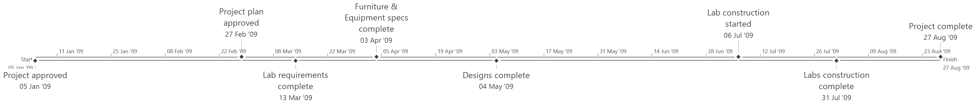

Milestone | Date
Project approved | 05 Jan '09
Project plan approved | 27 Feb '09
Lab requirements complete | 13 Mar '09
Furniture & Equipment specs complete | 03 Apr '09
Designs complete | 04 May '09
Lab construction started | 06 Jul '09
Labs construction complete | 31 Jul '09
Project complete | 27 Aug '09

Project Budget
The total budget for this project is $1,665,000. This includes a 10% contingency reserve amount and only reflects the direct costs associated with this project. This budget specifically does not include the overhead costs associated with labour or materials.

Task Expense Summary
The following is a breakdown of the estimated costs by project phase including labour and material costs and contingency reserves:

Summary Tasks | Costs
Project Management | $38,001
Design | $101,120
Construction
Borlaug Building | $271,400
Marquez Library | $271,400
Salam Center | $407,100
Sen Building | $407,100
Commissioning | $17,600
Sub-total | $1,513,721
Contingency | $151,279
Total | $1,665,000

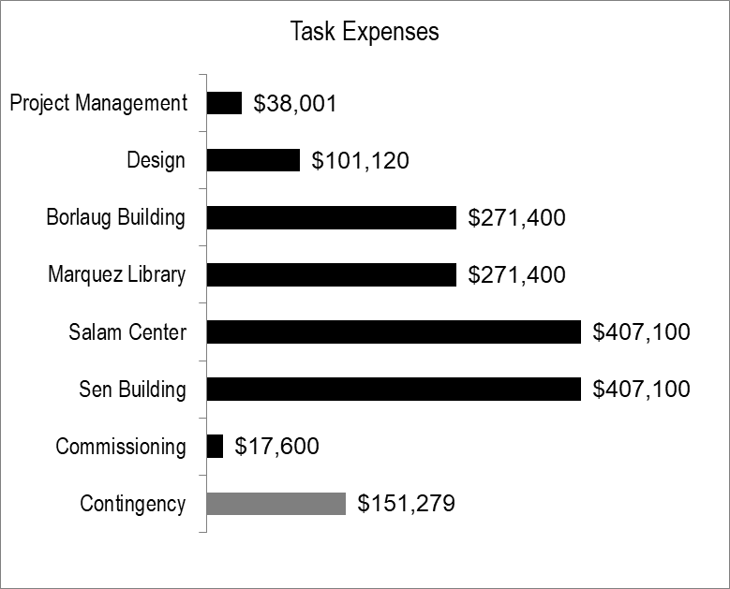

Resource Expense Summary
The following table and chart represent the project baseline costs by resource type:

Resource Group | Costs
Administration | $29,521
Design | $127,200
Equipment | $958,000
Furniture | $199,000
General Contractor | $200,000
Sub-total | $1,513,721
Contingency | $151,279
Total | $1,665,000

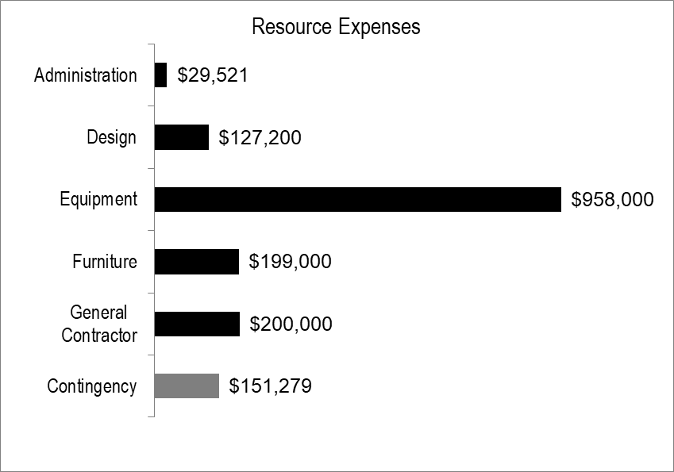

Project Cash Flow Summary
The following table and chart represents the project expenses over time.

Tasks | Jan | Feb | Mar | Apr | May | Jun | Jul | Aug
Project Management | $4,100 | $17,700 | $2,097 | $2,002 | $1,907 | $2,065 | $1,985 | $6,143
Design |  |  | $40,016 | $59,664 | $1,440
Construction |  |  |  |  |  |  | $1,357,000
Commissioning |  |  |  | $1,120 | $1,680 | $0 | $0 | $14,800
Sub-total | $4,100 | $17,700 | $42,113 | $62,786 | $5,027 | $2,065 | $1,358,985 | $20,943
Cumulative total | $4,100 | $21,800 | $63,913 | $126,700 | $131,726 | $133,792 | $1,492,777 | $1,513,721
Total with contingency | $1,665,000 | $1,665,000 | $1,665,000 | $1,665,000 | $1,665,000 | $1,665,000 | $1,665,000 | $1,665,000

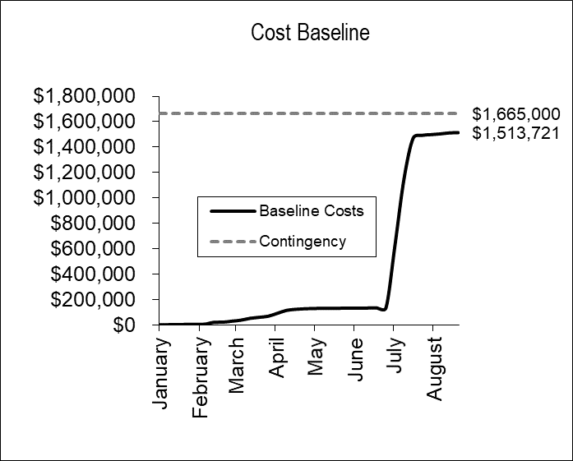

Project Risk Management

Risk Planning Process
This project followed a systematic, proactive approach to risk planning, which involved as many stakeholders as feasible. The processes for risk planning was:
- Risk identification – identified possible risk events that could occur on the project, the triggers that could precipitate the risk, and the symptoms that would indicate that the risk occurred.
- Risk qualification – determined the qualitative probability and impact of the risks, based on stakeholders’ input, to prioritize the risks for further planning actions.
- Risk quantification – high score risks were analysed further to quantify their probability in percentage and their impacts in cost, time or quality measures. The result of quantification is the risk exposure, which is the product of the probability and impact values.
- Risk response development – proactive risk response strategies were developed reduce, transfer or eliminate unfavourable risks and exploit, enhance or share favourable risks. Some risks had contingency plans and fallback plans developed in case the risks occur.

Risk Register
The following table represents only the highest exposure risks on this project.

Risk Event | Exposure | Response Strategy | Responsibility
Project funding is reduced by more than 25% during project planning. | $75,000 | Establish full project funding approval as early as possible, with commitment to contracts as top priority. | Sponsor

Communication Plan

Project Manager Communications Responsibilities
The project manager will manage all project communications, including any internal and external communications. The project manager will provide templates for reports to the appropriate project team members to report their progress.

The project manager will also provide task assignment lists to each of the resources with the upcoming tasks assigned to each resource.

The project manager will communicate any critical changes and risks impacting project scope, cost, and schedule, to the project sponsor. The project manager will meet the project sponsor monthly, or as needed. The project manager will communicate to the sponsor via monthly progress reports and variance reports.

The project sponsor and the project manager will communicate any changes requiring approval and any impacts related to changes to the Steering Committee. The sponsor will also communicate project status to the committee via quarterly reports presenting progress, variance, trends and forecast as required.

Project Team Communications Responsibilities
The project team will ensure the project status is reported to the project manager on a weekly basis, or immediately for critical issues. The project team will be critical in assisting the project manager with the development, maintenance, and final closing of the Communications Management Plan. They will be responsible for providing the project manager input towards the Communications Management Plan.

Each project team member will be responsible for communicating the status of his or her assigned tasks within the project on a weekly basis. Each team member will be assigned tasks from the project schedule depending on their expertise from the project manager. Any issues or requests must be communicated to the project manager as soon as possible.

Teams will meet bi-weekly with project manager and/or project sponsor (as appropriate) and present information related to assigned tasks and present any new related identified tasks.

The Team members will communicate via their weekly status reports, and verbally during status meetings any issues that may impact project cost, schedule, scope, and/or quality.

Reporting
The following table outlines the reports to be generated and distributed throughout this project:

Report Type | Timing | Recipients | Responsible
Periodic Task Progress Reports | Bi-weekly | Project Manager | Team, Sub-contractors
Project Performance Reports | Monthly | Management | Project Manager
Upcoming Activity Report | Weekly | Team, Sub-contractors | Project Manager
Project Closeout Report | On Close | Management | Project Manager
Lessons Learned Report | On Close | All Stakeholders | Project Manager

Meetings
The following table outlines the meetings to be held throughout this project:

Meeting Type | Timing | Participants
Initiating/Planning meetings | As necessary | PM, IS Director, Fac. Mgr., Procurement Mgr., Consultants
Project Kick-off meeting | Execution Start | PM, Management, Team
Project Progress meetings | Bi-weekly  As necessary | PM, Team
Project Status meetings | Monthly | PM, Sponsor
Closeout meetings | On Phase close  On Project close | PM, Team, Management

Key Contact Information
The following table outlines the key contacts on this project:

Contact | Role | E-mail | Telephone | Urgent
Kazaki Mikami | Sponsor | kmakami@emanon.edu | 604-555-4321 | 778-555-4321
Rebecca Brown | Project Manager | rbrown@emanon.edu | 604-555-7625 | 778-555-7625
Dev Nilsson | IS Director | dnilsson@emanon.edu | 604-555-7633 | 778-555-7633
Dan Woodrum | Facilities Director | dwoodrum@emanon.edu | 604-555-7651 | 778-555-7651
Len Powell | Facilities Manager | lpowell@emanon.edu | 604-555-7653 | 778-555-7653
Milena Galván | Senior Purchaser | mgalvan@emanon.edu | 604-555-7646 | 778-555-7646
Csenger Szatmári | Interior Designer | csenger@idesign.fic | 604-126-3953 | 778-126-3953
Liesbeth Brandt | Architect | liesbeth.brandt@arch.fic | 604-124-4222 | 778-124-4222
Saara Harila | Mech. Consultant | s.harila@mechanical.fic | 604-123-5627 | 778-123-5627
Ming Ku | Electrical Consultant | mku@electriciansrus.fic | 604-125-5511 | 778-125-5511
Alterio Lugo | Security Consultant | alterio@secureicon.fic | 604-129-6134 | 778-129-6134
Max Jaeger | Comm. Consultant | mjaeger@comcom.fic | 604-127-8945 | 778-127-8945
Jennifer Lane | General Contractor | jlane@laneconstruction.fic | 604-128-9407 | 778-128-9407

Change Control

Process
The following process will be used to manage change and change requests/orders:
- Any potential change that impacts the project’s scope, schedule, cost, or resulting deliverables will be documented on a Change Control Form.
- The change Initiator or Discoverer prepares the Change Control Form and documents the impact the change will have on the project.
- The Project Manager and Sponsor review the Change Control Form and decide if the change is in or out of the agreed project scope. The Sponsor determines if the scope revision should be approved and seeks additional funding if required.
- Approved changes will be grouped into a formal Contract Amendment as needed.
- Once accepted, the Project Manager will revise the project plan baseline to reflect the accepted change. Any deliverable content that is expected to change will be documented in the Change Control Form. The contents of the Change Control Form (and any related documentation) will signify an official amendment to the relevant sections of the plan or charter.

Project Plan Approval
The following signature indicates approval of the information, terms and conditions, and specifications presented in this document and all supporting documents. This document is supplemental to the contract and will be considered part of the agreement between the parties. Any amendments to the services provided under this project plan must be documented and accepted by both parties using change control.

Kazaki Mikami |  | 13 March 2009
Kazaki Mikami |  | Date
President, Emanon College

